Rendered To:

Authorization: Sales Order:

Calibration Laboratory: Labsphere, Inc., Reflectance Calibration Laboratory
231 Shaker Street
North Sutton, NH 03260
Tel 603-927-4266 Fax 603-927-4694

Description of Calibrated Items
One white diffuse reflectance sample, model SRT-99-050 Reflectance Target, serial number 99AA03-1213-7882

Calibration
8°/Hemispherical (8/h) Spectral Reflectance Calibration over the range 250 – 2500nm, reported at 50nm intervals

Description of Calibration
The calibration items are measured using a Perkin Elmer Lambda 900 or Lambda 950 dual beam spectrophotometer with LambdaX 150mm InGaAs RSA integrating sphere reflectance accessories which perform the 8/h reflectance measurements. The instrument used for the measurement of the calibrated items is identified with an X in Table I below.

Table I Measurement Instrument and Accessory

Spectrophotometer | Lambda 900A S/N 101N 3060902 | Lambda 950B, S/N: 950N3110101 | Lambda 950C SN: 950N9031801
Accessory | LambdaX 150mm InGaAs RSA  Serial No. 0508182129 | LambdaX 150mm InGaAs RSA  Serial No. 0508182127 | LambdaX 150mm InGaAs RSA  Serial No. 0508182128
Instrument Used | X

The integrating sphere diameter is 150 mm, the sample port diameter is 25 mm, and the interior material is Spectralon. The reference standard and sample piece are placed sequentially in the sample port of the sphere. The reference beam of the instrument acts as an auxiliary beam to correct for substitution error in the sphere. The calibration of the instrument follows the NIST method of utilizing pressed polytetrafluoroethylene (PTFE) as the reference standard.

Uncertainty values take into account the uncertainties of the pressed PTFE reference standard. The 8/h spectral reflectance of the sample R_{S} at each wavelength λ was calculated from:

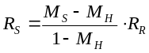
Eq. 1

where:
M_{S} is the instrument’s relative measurement of the reflectance of the calibration item
M_{H} is the instrument’s relative measurement of the reflectance of an open sample port and measures the effect of stray light overfilling the sample port
R_{R} is the 8/h spectral reflectance of the pressed PTFE reference standard.

The instrument’s relative measured reflectances, M_{S} and M_{H} are equivalent to:

Eq. 2 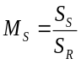

and

Eq. 3 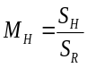

where:
S_{R} is the signal with the reference standard in place
S_{S} is the signal with the calibration item in place
S_{H} is the signal with an open port

Therefore, the 8/h spectral reflectance of the calibration item R_{S} at each wavelength λ is equivalent to:

Eq. 4 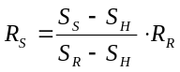

The final 8/h spectral reflectance is obtained by averaging the values from three scans.

Sources of uncertainty are:
  - the 8/h spectral reflectance of the pressed PTFE reference standard
  - nonuniformity across surfaces of the reference standard
  - nonuniformity across the surface of the calibration item
  - residual uncertainty in the correction for extraneous light
  - nonlinearity of the instrument
  - effect of wavelength error
  - random noise in the measurements

The individual contributions to uncertainty are combined by adding in quadrature (root-sum-square). The quadrature sum is multiplied by a coverage factor (k) to generate the expanded uncertainty. The coverage factor is chosen to provide a confidence level of 95%. For effective degrees of freedom of thirty or greater, k = 2.0. For lower degrees of freedom a larger coverage factor is used representing the coverage factor necessary to provide a confidence level of 95% for a t-distribution with the corresponding degrees of freedom. Reference Table IV for the expended uncertainty of the calibration results.

Calibrated by:
Title: Optical Calibration Technician

Approved by:

General Information

- The values in Table III apply only to the central 14 mm by 6 mm area of the items for measurement geometry 8/h.

- The report of calibration may not be reproduced except in full without the written consent of this laboratory.

- This report must not be used to claim product certification, approval, or endorsement by NVLAP, NIST, or any agency of the federal government.

Table III. 8/h spectral reflectance R_{s} as a function of wavelength λ

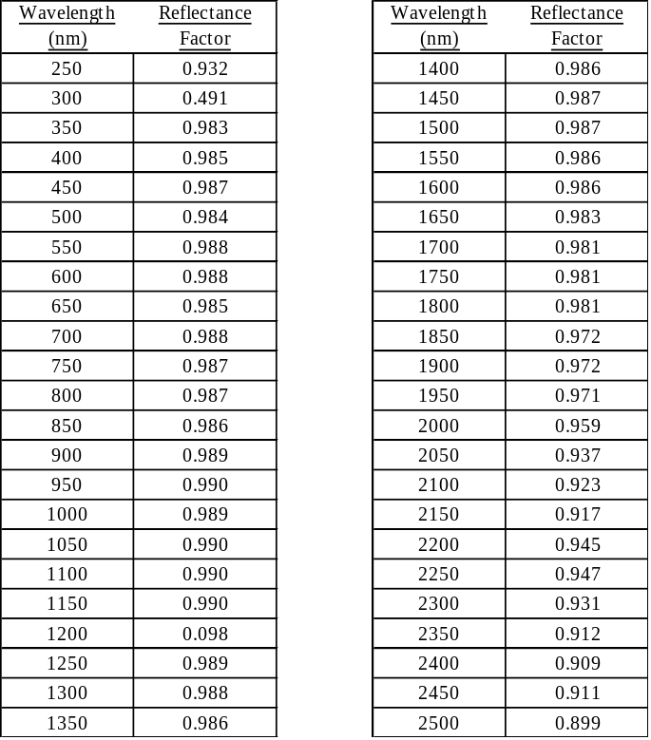

Graph I. 8/h spectral reflectance R_{s} as a function of wavelength

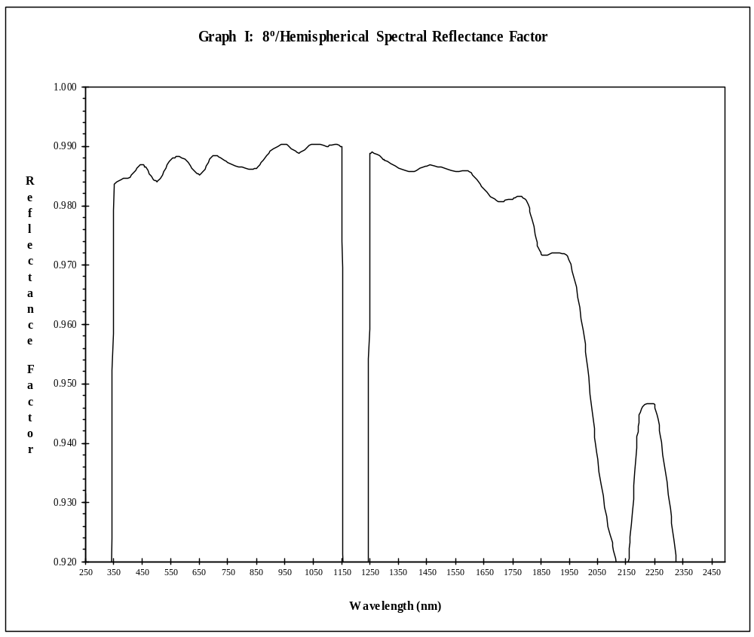

Table IV Uncertainty contributions and expanded uncertainty (k=2) of the 8/h spectral reflectance for the measured sample

CALIBRATION AND MEASUREMENT CAPABILITIES (CMC) ^{Notes 1,2}
Measured Parameter or  Device Calibrated | Range | Uncertainty (k=2) ^{Note 3,5} | Remarks
OPTICAL RADIATION
Photometric (20/O02)
Relative Reflectance at Wavelength Shown Below: |  |  | Relative reflectance is a dimensionless quantity
250 nm to 600 nm | up to 0.02 | 0.0016
 | > 0.02 to 0.05 | 0.0029
 | > 0.05 to 0.10 | 0.012
 | > 0.10 to 0.20 | 0.012
 | > 0.20 to 0.50 | 0.0054
 | > 0.50 to 0.80 | 0.0054
 | > 0.80 to 0.99 | 0.0053
601 nm to 1500 nm | up to 0.02 | 0.0017
 | > 0.02 to 0.05 | 0.0022
 | > 0.05 to 0.10 | 0.0025
 | > 0.10 to 0.20 | 0.0052
 | > 0.20 to 0.50 | 0.0064
 | > 0.50 to 0.80 | 0.0064
 | > 0.80 to 0.99 | 0.0049
1501 nm to 2200 nm | up to 0.02 | 0.0090
 | > 0.02 to 0.05 | 0.0090
 | > 0.05 to 0.10 | 0.015
 | > 0.10 to 0.20 | 0.015
 | > 0.20 to 0.50 | 0.0099
 | > 0.50 to 0.80 | 0.0083
 | > 0.80 to 0.99 | 0.0088
2201 nm to 2500 nm | up to 0.02 | 0.054
 | > 0.02 to 0.05 | 0.054
 | > 0.05 to 0.10 | 0.043
 | > 0.10 to 0.20 | 0.043
 | > 0.20 to 0.50 | 0.035
 | > 0.50 to 0.80 | 0.028
 | > 0.80 to 0.99 | 0.032
END

Notes
Note 1: A Calibration and Measurement Capability (CMC) is a description of the best result of a calibration or measurement (result with the smallest uncertainty of measurement) that is available to the laboratory’s customers under normal conditions, when performing more or less routine calibrations of nearly ideal measurement standards or instruments. The CMC is described in the laboratory’s scope of accreditation by: the measurement parameter/device being calibrated, the measurement range, the uncertainty associated with that range (see note 3), and remarks on additional parameters, if applicable.

Note 2: Calibration and Measurement Capabilities are traceable to the national measurement standards of the U.S. or to the national measurement standards of other countries and are thus traceable to the internationally accepted representation of the appropriate SI (Système International) unit.

Note 3: The uncertainty associated with a measurement in a CMC is an expanded uncertainty using a coverage factor, k = 2, with a level of confidence of approximately 95 %. Units for the measurand and its uncertainty are to match. Exceptions to this occur when marketplace practice employs mixed units, such as when the artifact to be measured is labeled in non-SI units and the uncertainty is given in SI units (Example: 5 lb weight with uncertainty given in mg).
Note 3a: The uncertainty of a specific calibration by the laboratory may be greater than the uncertainty in the CMC due to the condition and behavior of the customer's device and specific circumstances of the calibration. The uncertainties quoted do not include possible effects on the calibrated device of transportation, long term stability, or intended use.
Note 3b: As the CMC represents the best measurement results achievable under normal conditions, the accredited calibration laboratory shall not report smaller uncertainty of measurement than that given in a CMC for calibrations or measurements covered by that CMC.
Note 3c: As described in Note 1, CMCs cover calibrations and measurements that are available to the laboratory’s customers under normal conditions. However, the laboratory may have the capability to offer special tests, employing special conditions, which yield calibration or measurement results with lower uncertainties. Such special tests are not covered by the CMCs and are outside the laboratory’s scope of accreditation. In this case, NVLAP requirements for the labeling, on calibration reports, of results outside the laboratory’s scope of accreditation apply. These requirements are set out in Annex A.1.h. of NIST Handbook 150, Procedures and General Requirements.

Note 4: Uncertainties associated with field service calibration may be greater as they incorporate on-site environmental contributions, transportation effects, or other factors that affect the measurements. (This note applies only if marked in the body of the scope.)

Note 5: Values listed with percent (%) are percent of reading or generated value unless otherwise noted.

Note 6: NVLAP accreditation is the formal recognition of specific calibration capabilities. Neither NVLAP nor NIST guarantee the accuracy of individual calibrations made by accredited laboratories.

Note 7: See NIST Handbook 150 for further explanation of these notes.

Revision History

REV | DESCRIPTION | APPROVAL
00 | Initial release | Quality Mgr: T. Smith  VP Eng: D. Scharpf  Signature on file 1/7/14
01 | Revised ot reference Pressed PTFE and validate with Spectralon calibrated by NIST | Orig: G. McKee  Quality Mgr: D. Grossman  VP Eng: D. Scharpf  Signature on file 4/9/14
02 | Removed NIST traceability through Master Standard | Orig: T. Smith  Quality Mgr: H. LaBelle  Dir Eng: D. Scharpf
03 | Updated accessory  Updated logo | Vp Eng D Scharpf  Ops. Eng mgr. T Smith  Quality S Bowers  Signatures on file 11/18/19
04 | Updated Lambda 900B to Lambda 950B | Orig D Drew  Vp Eng D Scharpf  Quality S Bowers  Signatures on file 1/10/2020

Wiedner V.R., and Hsia, J. J. “Reflection Properties of Pressed Polytetrafluoroethylene Powder”, J.Opt.Soc.Am., Vol71, 1981, pp856-861
Barnes, P.Y., Early, E.A., and Parr, A.C., “NIST Measuremetn Services: Spectral Reflectance,” U.S. Dept. of Commerce, 1998.

